

CSA0501-DATABASE MANAGEMENT SYSTEMS

LAB EXPERIMENTS DATE: 31/07/2026

EXPERIMENT 13– Simple Programming using CASE and LOOP

AIM: To learn how to use MySQL CASE and LOOP statements to execute a block of code repeatedly based on a condition.
PROCEDURE:
- Select the required database using the USE command.
- Create a function using the CASE statement.
- Execute the function and display the result.
- Create a procedure using the LOOP and ITERATE statements.
- Repeat the loop until the specified condition is satisfied.
- Execute the procedure and verify the output.
- Confirm successful execution of both programs.
PROGRAM:

1 . CASE

Here we classify the pet based on its total value:

total <= 4 → Low

total <= 6 → Average

Otherwise → High

DELIMITER //

CREATE FUNCTION pet_level(total_value INT)

RETURNS VARCHAR(20)

DETERMINISTIC

BEGIN

DECLARE pet_category VARCHAR(20);

CASE

WHEN total_value <= 4 THEN

SET pet_category = 'Low';

WHEN total_value <= 6 THEN

SET pet_category = 'Average';

ELSE

SET pet_category = 'High';

END CASE;

RETURN pet_category;

END //

DELIMITER ;

OUTPUT:

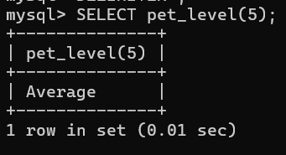

2 . LOOP with ITERATE
This program repeatedly increases the value until it reaches 10.
DELIMITER //
CREATE PROCEDURE pet_loop()
BEGIN
DECLARE x INT DEFAULT 0;
pet_loop_label: LOOP
SET x = x + 1;
IF x < 10 THEN
ITERATE pet_loop_label;
END IF;
LEAVE pet_loop_label;
END LOOP pet_loop_label;
SELECT x;
END //
DELIMITER ;
OUTPUT:

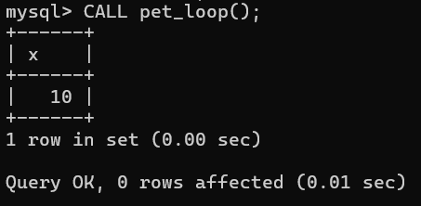

RESULT: The simple programming exercises using CASE and LOOP statements were executed successfully. The required outputs were obtained correctly.
.

